Minutes of the Meeting of the Parish Council – Wednesday 1st November 2023
Present;
Councillors: Cllr Page, Cllr Tomlinson, Cllr Bull, Cllr Bailey, Cllr Reader
Also present C Holmes; 2 Parishioners

- Councillor Co-option

Anslow Parish Council welcomed Alexandra Reader. Proposed by Cllr Bull and seconded by Cllr Page. All in favour

Action: Clerk to set up emails, update the website and send of Register of Interests.

- Apologies for Absence

Cllr Thompstone, Cllr White; Cllr Gaskin; Cllr Smedley, Cllr Jeans

- Declarations of Interest

None
- Chair’s Welcome

Cllr Page explained that he would be chairing the meeting this evening in the absence of Cllr Jeans.
Cllr Page welcomed the new councillor and the parishioners that were present.

- Public Forum

The parishioner discussed the flooding issues that had occurred in the village with particular focus on her property and the issues she is facing from the runoff of a farmer’s field. Cllr Page requested that the parishioner pass further details on to the clerk.
It was agreed that the parish council would support the parishioner with pursuing the issue with Staffs County Council.

Action: Clerk to request further information from Staffs County Council

- Minutes of the Meeting of the Parish Council held on 13th September 2023
All agreed to be a true record of the meeting.
Action: Clerk to convert to upload to website

- Matters arising from those minutes

Item 11 – Chasing of speed limit signage in the absence of the traffic calming work. The signs are now present on either side of the road.
- Clerk’s Report: to include banking changes, finance & correspondence.

CORRESPONDENCE & ONGOING MATTERS

Mid-year audit undertaken with no issues found.

Work on the clearing of the drains is being chased regularly with Richard Rayson and awaiting confirmation as to when the work will be finalised.

Register of Interest sent to ESBC for Cllr Jane Bailey and added to the website.

Phone box key has been handed to the parishioner wanting to start an honesty box.

Potholes still awaited outside the school.

Still awaiting information regarding possible groups for the CCF funding

Remembrance service organised and will be taking place on 11th November at 10.45am

Removal of lamp-post mounted bin reported.

Confirmation from Cllr Philip White that the moving of the memorial bench is now at the top of the priority list with legal notice now displayed in the village.

Work has been generated to complete the work on the kerb outside the church.

Correspondence explaining that due to many factors such as the rise in costs generally and pressure of other work Robert Wilson is unable to plant the village planters after the upcoming winter planting. It was suggested that various groups associated with the village may like the opportunity to do different areas, e.g., the school for the central planters, etc. – Councillor Bailey suggested that the pots could be filled by villagers, including herself and partner, with the Parish Council paying for the cost of the plants. The Parish Council agreed to consider this option but emphasised that a solution or a mix of solutions has to be found for all the sites concerned in the village, namely the village green, the Valerie Lydon memorial garden (opposite the garden of remembrance) and Hopley Road - It was agreed for the clerk to check the contract terms.

Parishioner correspondence regarding loud music coming from the village hall on the weekends. – It was agreed for the clerk to pass this information on to the village hall.

Parishioner correspondence regarding poppies for the village – It was agreed for the parish council to donate £250 for these reusable items.

Parishioner correspondence regarding flooding on Longhedge Lane. This was reported and contact made with SCC to assist the parishioner immediately. Sandbags discussed with ESBC but unable to recontact the parishioner as the line would not connect. – It was agreed for the clerk to contact the parishioner for an update

Correspondence regarding a review of the S106 Agreement for Upper Outwoods Farm.

Action: Clerk to review Robert Wilson contract; Clerk to contact the village hall; Clerk to chase the flooding on Longhedge Lane update; Cllr Page to discuss possible CCF Funding projects with Cllr Jeans.

FINANCE
Date | Online Payment Number | Category | Invoice Detail | Invoice Amount
 |  |  |  | Net | VAT | Gross
09/10/2023 | OLP 85 | Clerks Salary | Sept | -£ 389.11 |  | -£ 389.11
09/10/2023 | OLP 86 | Clerks Salary | HMRC Sept | -£ 88.20 |  | -£ 88.20
01/11/2023 | OLP 87 | Clerks Salary | Oct | -£ 389.11 |  | -£ 389.11
01/11/2023 | OLP 88 | Clerks Salary | HMRC Oct | -£ 88.20 |  | -£ 88.20
01/11/2023 | OLP 89 | Computer Costs | Microsoft | -£ 59.99 |  | -£ 59.99
01/11/2023 | OLP 90 | Room Hire |  | -£ 16.00 |  | -£ 16.00
01/11/2023 | OLP 91 | Misc & Donations | Wreaths | -£ 58.34 |  | -£ 58.34
01/11/2023 | OLP 92 | Planters & Village Maintenance | Winter Planting | -£ 398.00 |  | -£ 398.00

The Following payments were approved by the council.

Balance at 31.10.23
Treasurers Account - 56980463 | £15,575.15

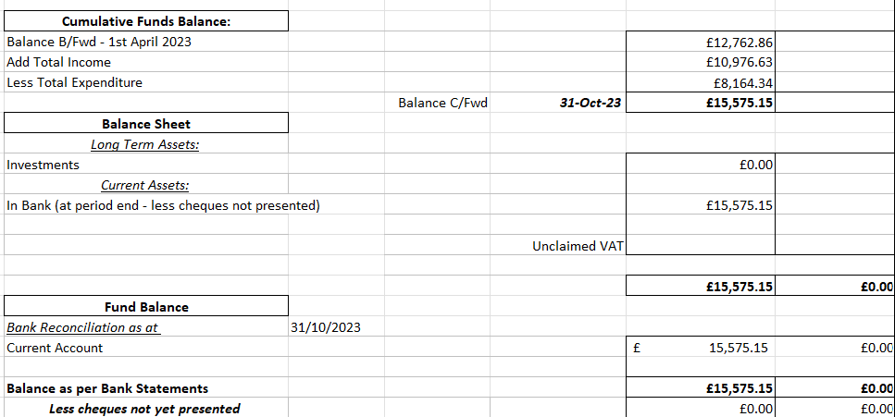

- Review planning applications
Status | Date | Planning No: | Site Address | Description | APC Comments | Decision
Registered | 20-01-2023 | P/2023/00064 | Home Farm Tutbury Road Needwood Staffordshire DE13 9PQ | Change of use of land to facilitate the formation of an outdoor equestrian arena / menage including fencing for personal use | No Objection
Registered | 23/05/2023 | P/2023/00571 | Anslow Eggs, Main Road, Anslow, Staffordshire, DE13 9QE | Change of use of an agricultural building to a flexible use of the unit falling within Class E (g) and Class B8 | Declaration of Interest – Cllr Thompstone  No Objection
Registered | 09/08/2023 | P/2023/00846 | Church Farm Tea Rooms, Hanbury Road, Anslow Gate, Staffordshire, DE13 9QT | Extension and reconfiguration of car park and retention of play equipment | No Objection
Registered | 07/09/2023 | P/2023/00959 | Mayfield Farm, Hanbury Road, Anslow Gate, Staffordshire, DE13 9QT | Erection of a part two storey part single storey rear extension with Juliet balcony and part two storey part first floor front infill extension. | No Objection | Permits
New | 12/10/2023 | P/2023/01041 | Barley Fields Farm, Bell House Lane, Anslow Gate, Staffordshire, DE13 9PA | Conversion of existing building to dwellinghouse.
P/2023/01041 – The parish council had no objections.

Action: Clerk to add comments to ESBC planning portal

- To provide an update on the traffic calming scheme
The parish council have been made aware that following an internal decision Staffs County Council are reviewing the double chicane. It was agreed that the parish council would like to invite Staffs County Council to meet on site and review and understand all the current options they are looking at as well as discussing the chicane already in place.
Action: Clerk to arrange meeting
- To provide an update on the village drainage works
Current work is being undertaken on this throughout the village. It was agreed to review further flooding that is a persistent problem on the bend of Hopley Road.
Action: Clerk to report to Staffs County Council
- To discuss the budget for 2024/2025
The Parish Council agreed to provide for an increase of 6% in the clerk’s salary to cover both the outstanding increase from March 2023 and the next increase due in March 2024.
Cllr Page asked for the item to be further added to the January agenda for final ratification.
Action: Clerk to send the revised budget to councillors and add to January agenda
- To discuss and approve the meeting dates for 2024
The following meeting dates were agreed.

Wednesday January 10th, 2024 - 6.30pm - Parish Council meeting
Wednesday March 13th, 2024 - 6.30pm - Parish Council meeting
Wednesday May 8th, 2024 - 6.30pm - Annual Meeting of the Parish Council/Annual Parish Meeting
Wednesday July 10th, 2024 - 6.30pm - Parish Council Meeting
NO AUGUST MEETING
Wednesday September 11th, 2024 - 6.30pm - Parish Council Meeting
Wednesday November 6th, 2024 - 6.30pm - Parish council meeting
Action: Clerk to update website and inform the village hall
- To discuss the upcoming remembrance services for 2023
Cllr Page discussed the two remembrance services, one on Saturday 11th November at the memorial garden and a further service at Holy Trinity Church on Sunday 12th November. The Parish Council will be represented at both services.
- A appoint a parish councillor to do a reading at the Holy Trinity Church on 16th December.
Cllr Page discussed the carol service taking place at Holy Trinity Church on 16th December at 4pm. A reading by parish councillors has been requested, and it was agreed for Cllr Bull & Cllr Bailey to undertake this.
Action: Clerk to inform the church as ask for the reading prior to the event
- To discuss parish councillor email addresses
The item was discussed with a proposal of undertaking Gmail emails instead of moving to new ones through the website as this has caused some difficulties. It was agreed to add this to the January agenda for further discussion.
Action: Clerk to add to January agenda
- Councillors’ Reports: Parish Cllrs, SCC Cllr Phillip White, ESBC Cllr Russell Lock and ESBC Cllr Simon Gaskin
Cllr Bailey discussed the pothole on Hanbury Road towards the T-junction. It was agreed for the clerk to report.

Cllr Lock discussed the ward improvement plan which is still open and the CCF funding which will close in January.

Action: Clerk to report pothole on Hanbury Road

Meeting closed at 19.54 pm

Date of next Parish Council Meeting – 10th January 2023

Parish Council Information can be found on the internet at – www.anslowparishcouncil.org.uk

Signed by the Chairman of the Parish Council

Name:

Date:

