Minutes of the Meeting of the Parish Council – Wednesday 13th March 2024
Present; Councillors: Cllr Jeans, Cllr Page, Cllr Tomlinson, Cllr Bull, Cllr Bailey, Cllr Reader.
Also present C Holmes; 7 Parishioners

- Apologies for Absence

Cllr White; Cllr Thompstone; Cllr Smedley; Cllr Gaskin; Cllr Lock

- Declarations of Interest

None
- Chair’s Welcome

The chair offered a welcome to all those who have attended and introduced the councillors to the public.

- Public Forum

A parishioner raised an issue with the highways on Hopley Road with 7 incidents having occurred in the past 14 months and one resulting in a car hitting his house. He stated that this is an area of the village with the most incidents and least actions so wanted to bring this to the attention of the parish council to reiterate the need to find the funds from Staffs County Council. The previous plan of a speed cushion was mentioned.

Cllr Jeans expressed sympathy for this as his car has also been hit on this road numerous times and therefore understands the problem that the parishioner is discussing. He went on to explain the loss of funding due to increasing costs since the section 106 money was received which has resulted in Staffs County Council having to remove Hopley Road from the current traffic calming plans. It was stated by Cllr White that in the next budget round they would try to find some funds to focus on Hopley Road. The parishioner asked if the parish council could make Staffs County Council aware of the HGV’s that are ignoring the weight limit restrictions and enquire about possible lower cost options such as children crossing warning triangle before the blister paved crossing point or Zig-zag Road markings either side of the crossing point to warn drivers they are approaching a pedestrian crossing. It was agreed for the clerk to review this.

A parishioner raised concern about the potholes in the village. This was reiterated by Cllr Bull & Cllr Bailey and further concern was raised about the speeding cars during the evening outside The Bell. Cllr Page stated that resurfacing is needed both there and outside The Acorn pub. The parish council have reported this numerous times on the Staffs County Council Report it page but Cllr Page encouraged parishioners to also report this issue.

A parishioner explained that they live on Outwoods Lane, and they have concerns regarding flooding. Severn Trent have been their numerous times, but this is still a persistent issue. It was agreed for the clerk to report this and to ask for guidance from the County Council.

Action: Clerk to contact Staffs County Council regarding Hopley Road lower cost options and the HGV’s ignoring the weight limit, Clerk to report flooding on Outwoods Lane and speak to Cllr White for guidance.

- Minutes of the Meeting of the Parish Council held on 10th January 2023.
All agreed to be a true record of the meeting.
Action: Clerk to convert to upload to website

- Matters arising from those minutes.

Item 11 – Cllr Readers email address. Clerk currently having some issues with the migration on 123 reg.

Action: Clerk to set up email address for Cllr Reader.
- Clerk’s Report: to include banking changes, finance & correspondence.

- CORRESPONDENCE & ONGOING MATTERS

All allotments now have tenants for 2024.

CCF Funding worked on with Events Committee, but we were unsuccessful due to not having a sperate bank account and therefore not meeting the criteria.

Firs Farm in Sudbury contacting regarding winter planting. Awaiting confirmation of a price. It was agreed for Cllr Bailey to have a conversation with the original builder to repair the one on Hopley Road. It was agreed to contact Anslow Nurseries for a further quote.

Cllr Reader’s details passed on to Rolleston Almhouse charity.

Parishioner contacted regarding the wildflower garden.

Parishioner contacted regarding the honesty box. Clerk to chase the key.

Defib serviced at The Bell and new battery and pads added.

Anslow Business Park defib added to The Circuit registry.

Staffs County Council and Severn Trent contacted regarding the work being undertaken on the village green. This has now been completed and we are waiting for the barriers to be removed.

Potholes reported at The Bell & outside The Acorn. Cllr White has explained that Main Road will be resurfaced but he will look to expedite this process. Cllr Bull has further reported this due to the graffiti and has been informed that these will be assessed. It was agreed for the clerk to chase this.

Blocked gullies reported.

Poppies removed from village.

Letter sent to landowners who need to trim their hedges.

Parked cars and traffic issues reported to PCSO, and some presence has been seen at school times.

Footpath repaired outside of the church.

Parishioner correspondence regarding the unfilled hole in The Green.

Tree preservation order on Henhurst Hill – TPO 454

Correspondence received regarding grant funding for Anslow Village Hall. It was agreed to support them in any grant applications.

Correspondence received regarding grant funding for Rolleston United Foundation.

Parishioner correspondence regarding P/2024/00096

Action: Clerk to chase Fir Farm and to contact Anslow Nurseries regarding the winter planting, Clerk to chase the key for the phone box, Clerk to chase the pothole repair outside the bell, clerk to reply to Anslow Village Hall regarding funding.

- FINANCE

The council agreed that the amount held in reserved funds for traffic calming was £5000. All in favour.
OLP 102 | Clerks Salary | Jan | -£ 416.77 |  | -£ 416.77
OLP 103 | Clerks Salary | HMRC Jan | -£ 95.20 |  | -£ 95.20
OLP 104 | Clerks Salary | Feb | -£ 416.77 |  | -£ 416.77
OLP 105 | Clerks Salary | HMRC Feb | -£ 95.20 |  | -£ 95.20
OLP 106 | Room Hire |  | -£ 16.00 |  | -£ 16.00
OLP 107 | Planters & Village Maintenance | Hedge Cutting | -£ 90.00 | -£ 18.00 | -£ 108.00
OLP 108 | Misc & Donations | Defib Repair | -£ 282.95 | -£ 56.59 | -£ 339.54
OLP 109 | Room Hire |  | -£ 16.00 |  | -£ 16.00
OLP 110 | Planters & Village Maintenance | Hedge Cutting | -£ 80.00 | -£ 16.00 | -£ 96.00
OLP 111 | Clerks Salary | March | -£ 416.77 |  | -£ 416.77
OLP 112 | Clerks Salary | HMRC Feb | -£ 95.20 |  | -£ 95.20

All payments were agreed by the council.

Balance at 29.02.24
Treasurers Account - 56980463 | £13,125.02
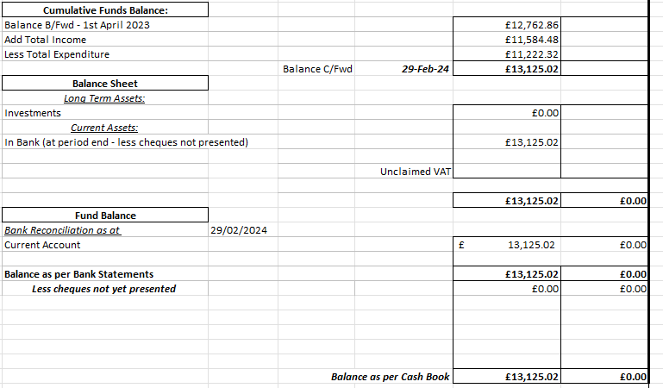

- Review planning applications.
Registered | 20-01-2023 | P/2023/00064 | Home Farm Tutbury Road Needwood Staffordshire DE13 9PQ | Change of use of land to facilitate the formation of an outdoor equestrian arena / menage including fencing for personal use | No Objection
Registered | 09/08/2023 | P/2023/00846 | Church Farm Tea Rooms, Hanbury Road, Anslow Gate, Staffordshire, DE13 9QT | Extension and reconfiguration of car park and retention of play equipment | No Objection
Registered | 12/10/2023 | P/2023/01041 | Barley Fields Farm, Bell House Lane, Anslow Gate, Staffordshire, DE13 9PA | Conversion of existing building to dwellinghouse. | No Objections
Registered | 01/11/2023 | P/2023/01064 | 7 Hopley Road, Anslow, Staffordshire, DE13 9PY | Retention of dropped kerb and formation of hard standing | No Objections | Permits
Registered | 23/02/2024 | P/2024/00065 | Oaks Farm, Burton Road, Needwood, Staffordshire, DE13 9PU | Conversion of single storey building to form residential annex including re-building of roof and part re-building of walls | Comments added regarding visibility for oncoming traffic.
New | 12/02/2024 | P/2024/00130 | Belmont Driving Range, Belmot Road, Needwood, Staffordshire, DE13 9PH | Conversion of golf driving range building to form 2 dwellings, including single storey extension on south, east and west elevation, parking and landscaping | The council raised a concern of the lack of sewage.
New | 22/02/2024 | P/2024/00173 | Church Farm, Hanbury Road, Anslow Gate, Staffordshire, DE13 9QT | Erection of single storey rear, part single part two storey side extensions, a porch and installation of a first floor side window and roof light on the north west elevation. | The council offered no objections
New | 28/02/2024 | P/2024/00096 | Dovecote Barn , Outwoods Lane, Burton upon Trent, Staffordshire, DE13 9QU | Outline application for the erection of a self build dwelling including details of layout & access and demolition of existing stables & storage building | Council raised concerns about the fit with the Neighbourhood plan. Incorrect postcode on planning statement raised.
New | 20/02/2024 | P/2024/00039 | The Burnt Gate , Hopley Road , Anslow , Burton-on-Trent , DE13 9PY, | Loft conversion to include two pitched roof dormers and 1 velux window to rear and and five velux windows to front | Neighbours have raised concerns that the windows could allow them to be overlooked.
New | 12/03/2024 | P/2024/00202 | Mayfield Farm, Hanbury Road, Anslow Gate, Staffordshire, DE13 9QT | Erection of part two storey rear including Juliet balcony, part first floor side, two storey front infil and single storey front extensions including canopy | The council offered no objections

- To provide an update on the traffic calming scheme
A meeting took place on site with the engineers and the councillors were shown where the second chicane could be sited but the council did feel that with it being further out from the village that it could allow drivers to pick up speed again.
The expressed that they are also looking at rubber road humps. The parish council are still awaiting a proposal from the meeting.
It was agreed for the clerk to chase Staffs County Council for an updated proposal and proceed.
Action: Clerk to contact Staffs Highways for an updated plan.
- To review and approve the asset register 2024.
The asset register was reviewed and approved. It was believed to be materially correct a further audit to take place in this financial year.
Action: Clerk to update the website.
- To review and approve the financial regulations 2024.
The financial regulations were reviewed and approved.
Action: Clerk to update the website.
- Councillors’ Reports: Parish Cllrs, SCC Cllr Phillip White, ESBC Cllr Russell Lock and ESBC Cllr Simon Gaskin
Cllr Jeans raised a point from Cllr Thompstone in relation to the battery-operated SID. The battery needs replacing at a cost of £58 + VAT. It was discussed that this SID could be fitted with a solar powered unit for a cost of £400 + VAT and £150 for fitting. This was agreed by the council.
Cllr Page discussed the potholes along Hanbury Road up to Hanbury crossroads and it was agreed to report them on the Staffs County Council report it site.
Bell House Lane was agreed to be reported as the number of potholes no longer allows cyclists to use the road.
Action: Clerk to action the new solar power unit on the SID, Clerk to report potholes on Hanbury Road, Clerk to report potholes on Bell House Lane.

Meeting closed at 20.08pm

The next Parish Council Meeting is the Annual Parish Council Meeting – 8th May 2024

Parish Council Information can be found on the internet at – www.anslowparishcouncil.org.uk

Signed by the Chairman of the Parish Council

Name:

Date:

