Minutes of the Meeting of the Parish Council – Wednesday 8th January 2025
Present; Councillors: Cllr Bull, Cllr Page, Cllr Bailey, Cllr Reader, Cllr Tomlinson, Cllr Thompstone
Also present C Holmes; 2 Parishioners

- Apologies for Absence

Cllr Gaskin, Cllr Lock, Cllr Smedley, Cllr Jeans

- Declarations of Interest

None
- Chair’s Welcome

The chair offered a welcome to all those who have attended.

- Public Forum

Parishioner came to thank the parish council for all the work that has been undertaken on the footpaths and bridlepaths.

- Minutes of the Meeting of the Parish Council held on 6th November 2024
All agreed to be a true record of the meeting.
Action: Clerk to convert to upload to website

- Matters arising from those minutes.

Item 7 – Awaiting SID data from Cllr Jeans

Action: Clerk to send to SCC
- Clerk’s Report: to include banking changes, finance & correspondence.

- CORRESPONDENCE & ONGOING MATTERS

Requests for costs for clearing of no17 footpath.

Precept request sent to ESBC

Potholes reported on Hopley Road, Main Road, Bushton Lane and outside Anslow nurseries. Further potholes were discussed and needs reporting.

Request made to SCC and ESBC regarding further 106 monies for the parish council. We have had no response, and 2 emails sent. It was agreed to ask Cllr Jeans to review this with Cllr White.

Flooding on Main Road reported. Escalate this to Richard Rayson as the tarmac down the drain is causing the flooding and needs to be looked at.

Booked on to a .gov.uk workshop in January to look at moving emails.

Zebra crossing discussed with SCC. I think this is something that we should look at working with Simon Cartledge on when the second phase is completed.

Correspondence from MP Jacob Collier regarding the traffic calming and concerns from a resident. Full explanation of the consultation process and the way in which SCC manage the projects sent in response.

Correspondence from Kate White in regard to potential ways to support riders in the village.

Parishioner correspondence regarding parents parking dangerously on Bushton Lane. It was discussed to place some of the parking buddies on Bushton Lane to see if this helps and the school have been made aware of the complaint.

Parishioner correspondence regarding overgrown hedgerows outside The Acorn pub.

Action: Clerk to report further potholes, Cllr Jeans to discuss 106 funds with Cllr White, Clerk to escalate Main Road flooding to SCC

- FINANCE
Date | Online Payment Number | Category | Invoice Detail | Invoice Amount
 |  |  |  | Net | VAT | Gross
02/12/2024 | OLP 147 | Clerks Salary | Salary | -£ 440.90 |  | -£ 440.90
19/12/2024 | OLP 148 | Allotment Insurance |  | -£ 184.73 |  | -£ 184.73
19/12/2024 | OLP 149 | Planters & Village Maintenance | Josh grounds maintenance | -£ 715.00 |  | -£ 715.00
02/01/2025 | OLP 150 | Clerks Salary | Salary | -£ 440.90 |  | -£ 440.90
08/01/2025 | OLP 151 | Stationary | stationary | -£ 112.89 |  | -£ 112.89
08/01/2025 | OLP 152 | Stationary | envelopes | -£ 4.39 |  | -£ 4.39
08/01/2025 | OLP 153 | Room Hire |  | -£ 18.00 |  | -£ 18.00
08/01/2025 | OLP 154 | Clerks Salary | HMRC | -£ 101.23 |  | -£ 101.23
08/01/2025 | OLP 155 | Clerks Salary | HMRC | -£ 101.23 |  | -£ 101.23

Balance at 31.12.24
Treasurers Account - 56980463 | £15,753.39
All payments agreed by the council.
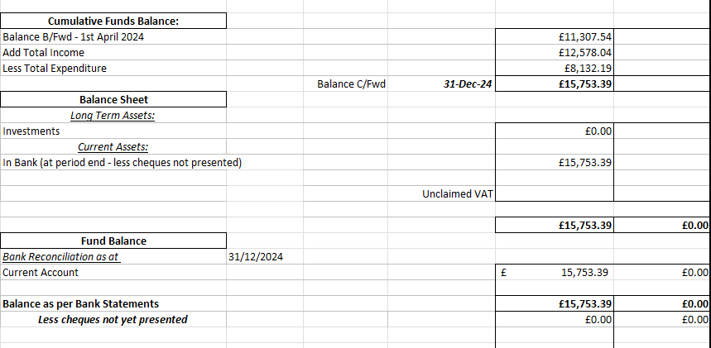
- Review planning applications

Status | Date | Planning No: | Site Address | Description | APC Comments | Decision
Registered | 20-01-2023 | P/2023/00064 | Home Farm Tutbury Road Needwood Staffordshire DE13 9PQ | Change of use of land to facilitate the formation of an outdoor equestrian arena / menage including fencing for personal use | No Objection
Registered | 09/08/2023 | P/2023/00846 | Church Farm Tea Rooms, Hanbury Road, Anslow Gate, Staffordshire, DE13 9QT | Extension and reconfiguration of car park and retention of play equipment | No Objection

Registered | 23/07/2024 | P/2024/00478 | Oaks Farm, Burton Road, Needwood, Staffordshire, DE13 9PU | Demolition of existing barn and erection of replacement agricultural building including formation of access track | No Objection
Registered | 23/07/2024 | P/2024/00096 | Dovecote Barn , Outwoods Lane, Burton upon Trent, Staffordshire, DE13 9QU | Appeal | Same comments as previously added.
Registered | 04/09/2024 | P/2024/00889 | The Acorns, Burton Road, Needwood, Staffordshire, DE13 9PU | Erection of a single storey side extension to existing Coach House | No Objection | Permits
Registered | 25/09/2024 | P/2024/00808 | Church Farm Tea Rooms, Hanbury Road, Anslow Gate, Staffordshire, DE13 9QT | Retention of a marquee for a temporary period of up to 6 months in a calendar year | No Objection | Refuses
Registered | 16/10/2024 | P/2024/01006 | The Yews, Tutbury Road, Needwood, Staffordshire, DE13 9PQ | Listed Building Consent for the erection of a detached triple garage/carport | No Objection
Registered | 16/10/2024 | P/2024/00989 | The Yews, Tutbury Road, Needwood, Staffordshire, DE13 9PQ | Erection of a detached triple garage/carport | No Objection | Permits
Registered | 22/10/2024 | P/2024/01011 | Land adj to 67 Hopley Road, Anslow, Staffordshire, DE13 9PZ | Erection of a detached self-build dwelling | It was discussed that the planning looks very tight. Concerns with road access and availability of parking. Materials used.
Registered | 04/11/2024 | P/2024/01079 | Mayfield, Bushton Lane, Anslow, Staffordshire, DE13 9QL | Erection of single storey front, side and rear extensions, rear dormer extension including balcony and screen | No Objections | Permits
New | 28/112024 | P/2024/01180 | 15 Bushton Lane, Anslow, Staffordshire, DE13 9QL | Erection of a single storey rear extension and conversion of garage to form additional living accommodation | The parish council had no comments.

- To discuss the grounds maintenance contracts
We have requested 3 quotes for the ground’s maintenance contract and received 2. It was agreed to appoint Joshua Billings alongside his work with the planters.
Action: Clerk to add to appoint the contractor.
- To discuss the progress with the installation of fibre.
The fibre broadband project, facilitated through a community fibre partnership with Openreach, is being explored for Anslow. However, the project would need to be done in isolated sections, such as Hopley Road and Main Road, due to the area's size.
Key details include:
- A quote from BT for a section of the road was £9,000, with government grants of £500-£1,500 per property, potentially making it free for households.
- Once completed, properties would be eligible for full gigabit fibre connections (up to 1Gb/s).
The next steps for the project are:
- Register interest in the partnership.
- Gather support from local residents.
- Receive a final quote, including grant funding, which should ideally cover all costs.
- Confirm the project and proceed with BT's upgrade program.
- Set up an agreement via a shell company, costing around £100.
- BT will then upgrade street connections and install fibre in each property.
- Homeowners can then upgrade their broadband if desired, without affecting existing lines.
The entire process is expected to take around 6 months to complete. It was agreed to gauge interest in the project and to do this via letter drop.
Action: Clerk to gauge interest in who would like to apply for a grant.
- To review and approve the risk register
The risk register was reviewed and approved.
Action: Clerk to update the website
- To review and approve the general privacy policy
The general privacy policy was reviewed and approved.
Action: Clerk to update the website
- Councillors’ Reports: Parish Cllrs, SCC Cllr Phillip White, ESBC Cllr Russell Lock and ESBC Cllr Simon Gaskin
Cllr Page discussed finding a week when Longhedge lane would be completed. It was agreed for the clerk to chase this.
Flooding outside the allotment discussed.
Allotment hedges needing cutting was discussed.
Cllr Jeans discussed the letter regarding the crossing signage.
Action: Clerk to chase work completed on Longhedge lane, Clerk to report the flooding outside the allotment, Cllr Thompstone to look at having the allotment hedges cut

Meeting closed 19:26pm

The next Parish Council Meeting is– Wednesday 5th March 2025
Parish Council Information can be found on the internet at – www.anslowparishcouncil.org.uk

Signed by the Chairman of the Parish Council
Name:

Date:

