Minutes of the Meeting of the Parish Council – Wednesday 5th March 2025

Present; Councillors: Cllr Bull, Cllr Page, Cllr Bailey, Cllr Reader,   
Also present C Holmes; Cllr Smedley, 2 Parishioners

1. **Apologies for Absence**

Cllr Gaskin, Cllr Lock, Cllr Jeans, Cllr Thompstone, Cllr Tomlinson

1. **Declarations of Interest**

None

1. **Welcome from the chair**

The chair offered a welcome to all those who have attended.

1. **Public Forum**

Vanessa Winstone from the Rolleston United Foundation attended the meeting to discuss the small grant for 18-year-old going to university or on apprenticeships towards laptops or tools for the trade. The closing date for applications.

1. **Minutes of the Meeting of the Parish Council held on 8th January 2025**

All agreed to be a true record of the meeting.

Action: Clerk to convert to upload to website

1. **Matters arising from those minutes.**

Item 6 – Awaiting SID data from Cllr Jeans

Action: Clerk to send to SCC

1. **Clerk’s Report: to include banking changes, finance & correspondence.**

* **CORRESPONDENCE & ONGOING MATTERS**

Potholes have all been reported on Hopley Road, Main Road and Bushton Lane

Flooding on Main Road and the allotment have been reported to Staffs CC

Contractor officially appointed so any jobs are now able to be completed

Application sent to BT Outreach in relation to fibre. Awaiting to hear if we are eligible to move to the next stage.

Longhedge Lane works due to be completed in January with resurfacing in the summer.

Parishioner correspondence regarding fencing that has been put up on Hopley Road but none of the vegetation has been cut back making the footpath unusable if the field gate is closed. This has been reported to SCC.

Correspondence regarding the section 106 money explaining that no further funds are to be issues to Anslow Parish Council.

Parishioner correspondence regarding the cutting of the allotment hedge. **It was agreed to reach out to the grounds maintenance team to do this**.

An update from highways at Staffs County Council is suggesting that the work will be completed in the Easter holidays.

Attended a course - Moving to a .gov.uk domain would mean we are officially recognised as part of local government, which helps build trust with the public. It’s also more secure, as the government can monitor for vulnerabilities and provide some control over data. A key benefit is that if a councillor leaves, it will be much easier to manage and close their email account.

There are 29 approved providers that they suggest (out of 172) that can supply this service, and I’m planning to get quotes from a few of them. It looks like it will cost around £100-£150 more per year overall. These providers will also help us choose a suitable domain name (which has to include "-pc" or "parishcouncil") and can assist with an IT policy. If we’re happy with our current website and it meets accessibility requirements, they can transfer it for an upfront cost. If it needs updating, they can also rebuild it for an additional fee. Emails will also need to be paid for, but the cost is similar to standard providers – just not free like Hotmail or Gmail.

The government originally wanted to make this mandatory by 2027, but NALC has rejected that proposal.

Parishioner correspondence regarding vans parked fully on the pavement.

Action: Clerk to reach out to grounds maintenance to cut the hedge

* **FINANCE**

|  |  |  |  |  |  |  |
| --- | --- | --- | --- | --- | --- | --- |
| Date | Online Payment Number | Category | Invoice Detail | Invoice Amount | | |
| Net | VAT | Gross |
| 03/02/2025 | OLP 156 | Clerks Salary | Salary | -£ 440.90 |  | -£ 440.90 |
| 05/03/2025 | OLP 157 | Clerks Salary | HMRC | -£ 101.23 |  | -£ 101.23 |
| 05/03/2025 | OLP 158 | Clerks Salary | Salary | -£ 440.90 |  | -£ 440.90 |
| 05/03/2025 | OLP 159 | Clerks Salary | HMRC | -£ 101.23 |  | -£ 101.23 |
| 05/03/2025 | OLP 160 | Room Hire |  | -£ 18.00 |  | -£ 18.00 |
| 05/03/2025 | OLP 161 | Planters & Village Maintenance | Hedges | -£ 80.00 | -£ 16.00 | -£ 96.00 |
| 05/03/2025 | OLP 162 | Misc & Donations | Website Hosting | -£ 134.25 | -£ 26.85 | -£ 161.10 |
| 05/03/2025 | OLP 163 | Misc & Donations | Domain Renewal | -£ 12.99 |  | -£ 12.99 |

**All payments agreed.**

|  |  |
| --- | --- |
| **Balance at 28.02.25** | |
| Treasurers Account - 56980463 | **£14,617.45** |

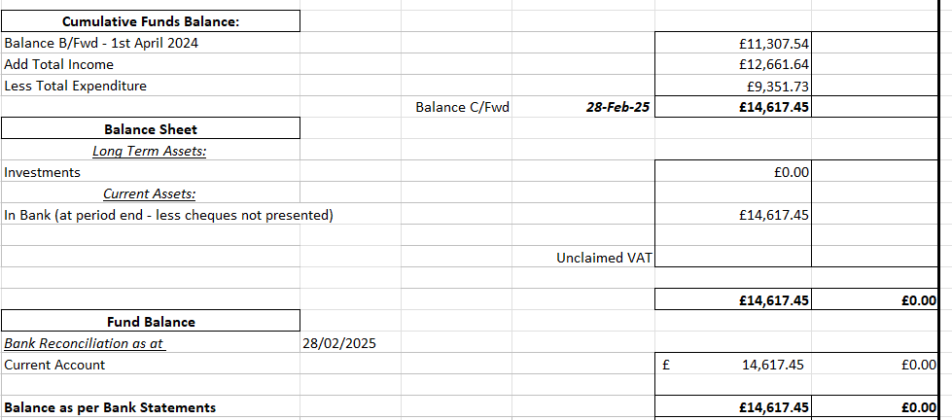

1. **Review planning applications**

|  |  |  |  |  |  |  |
| --- | --- | --- | --- | --- | --- | --- |
| **Status** | **Date** | **Planning No:** | **Site Address** | **Description** | **APC Comments** | **Decision** |
| Registered | 20-01-2023 | [P/2023/00064](http://www.eaststaffsbc.gov.uk/Northgate/PlanningExplorer/Generic/StdDetails.aspx?PT=Planning%20Applications%20On-Line&TYPE=PL/PlanningPK.xml&PARAM0=639248&XSLT=/Northgate/PlanningExplorer/SiteFiles/Skins/EastStaffs/xslt/PL/PLDetails.xslt&FT=Planning%20Application%20Details&PUBLIC=Y&DAURI=PLANNING&XMLSIDE=/Northgate/PlanningExplorer/SiteFiles/Skins/EastStaffs/Menus/PL.xml) | Home Farm Tutbury Road Needwood Staffordshire DE13 9PQ | Change of use of land to facilitate the formation of an outdoor equestrian arena / menage including fencing for personal use | No Objection |  |
| Registered | 09/08/2023 | P/2023/00846 | Church Farm Tea Rooms, Hanbury Road, Anslow Gate, Staffordshire, DE13 9QT | Extension and reconfiguration of car park and retention of play equipment | No Objection |  |

|  |  |  |  |  |  |  |
| --- | --- | --- | --- | --- | --- | --- |
| Registered | 23/07/2024 | P/2024/00478 | Oaks Farm, Burton Road, Needwood, Staffordshire, DE13 9PU | Demolition of existing barn and erection of replacement agricultural building including formation of access track | No Objection | Permits |
| Registered | 23/07/2024 | P/2024/00096 | Dovecote Barn , Outwoods Lane, Burton upon Trent, Staffordshire, DE13 9QU | Appeal | Same comments as previously added. | Dismissed |
| Registered | 04/09/2024 | P/2024/00889 | The Acorns, Burton Road, Needwood, Staffordshire, DE13 9PU | Erection of a single storey side extension to existing Coach House | No Objection | Permits |
| Registered | 25/09/2024 | P/2024/00808 | Church Farm Tea Rooms, Hanbury Road, Anslow Gate, Staffordshire, DE13 9QT | Retention of a marquee for a temporary period of up to 6 months in a calendar year | No Objection | Refuses |
| Registered | 16/10/2024 | P/2024/01006 | The Yews, Tutbury Road, Needwood, Staffordshire, DE13 9PQ | Listed Building Consent for the erection of a detached triple garage/carport | No Objection |  |
| Registered | 16/10/2024 | P/2024/00989 | The Yews, Tutbury Road, Needwood, Staffordshire, DE13 9PQ | Erection of a detached triple garage/carport | No Objection | Permits |
| Registered | 22/10/2024 | P/2024/01011 | Land adj to 67 Hopley Road, Anslow, Staffordshire, DE13 9PZ | Erection of a detached self-build dwelling | It was discussed that the planning looks very tight. Concerns with road access and availability of parking. Materials used. |  |
| Registered | 04/11/2024 | P/2024/01079 | Mayfield, Bushton Lane, Anslow, Staffordshire, DE13 9QL | Erection of single storey front, side and rear extensions, rear dormer extension including balcony and screen | No Objections | Permits |
| Registered | 28/112024 | P/2024/01180 | 15 Bushton Lane, Anslow, Staffordshire, DE13 9QL | Erection of a single storey rear extension and conversion of garage to form additional living accommodation | The parish council had no comments. | Conditional Approval |

1. **To discuss a potential Children Crossing sign on Hopley Road**

A letter has been sent to the County Council, and it was agreed that this would be looked at in the next traffic calming phase.

1. **To review and approve the Asset Register 2025**

The Asset Register was reviewed and approved.

Action: Clerk to add to website

1. **To approve the auditor for the Annual Governance & Accountability Return 2025/2026**

It was agreed to remain with Toplis & Associates.

Action: Clerk to inform Toplis & Associates

1. **Councillors’ Reports: Parish Cllrs, SCC Cllr Phillip White, ESBC Cllr Russell Lock and ESBC Cllr Simon Gaskin**

No Mow May was discussed, and it was agreed that we would ask for the memorial area and the green opposite to be removed.

The noticeboards were discussed, and it was agreed to obtain some prices.

Action: Clerk to ask for the memorial and the green to be exempt from No Mow May. Clerk to obtain noticeboard prices.

**Meeting closed 19.19pm**

The next Parish Council Meeting is the Annual Parish Council Meeting followed by the Annual Meeting of the Parish Council – **Wednesday 14th May 2025**

Parish Council Information can be found on the internet at – [www.anslowparishcouncil.org.uk](http://www.anslowparishcouncil.org.uk)

**Signed by the Chairman of the Parish Council**

**Name:**

**Date:**