Minutes of the Meeting of the Parish Council – Wednesday 7th January 2026
Present; Councillors: Cllr Jeans, Cllr Page, Cllr Bailey, Cllr Tomlinson, Cllr Thompstone
Also present C Holmes, Borough Councillor Lock; 5 Parishioners

- Apologies for Absence

Cllr Bull, Cllr Reader, Cllr Smedley

- Declarations of Interest

None
- Welcome from the chair

The chair welcomed everyone present at the meeting.

- Public Forum

A parishioner attended the meeting to discuss a recent planning application relating to Church Farm. The application had not yet been received by the Parish Council for comment.
It was explained that a 10-acre field behind Church Farm has recently been purchased. The field currently has no road access; however, proposals include expanding the existing car park. A highways survey undertaken on one of the busiest days indicated that an additional 30–40 parking spaces would be beneficial. The proposal therefore includes the creation of 52 car parking spaces. Some of these spaces would be paved, while others would use grass grid systems. The intention is to reduce on-road parking and encourage visitors to use the expanded parking area.
The planning application also includes a proposal for an additional barn. This would provide a wooden indoor play area to allow the business to operate in all seasons, rather than increasing the overall level of business activity. It was explained that the aim is to retain staff throughout the year, and an indoor facility would help make this possible.
A new visitor booking system has also been introduced to cap capacity and ensure visitor arrivals are staggered. The proposed barn would also remove the need to erect the marquee currently used and instead provide a permanent space suitable for school groups and special needs groups.
It was confirmed that the business would not extend its opening hours and would not operate in the evenings.

- Minutes of the Meeting of the Parish Council held on 7th January 2026
All agreed to be a true record of the meeting.
Action: Clerk to convert to upload to website

- Matters arising from those minutes.

Item 4: Awaiting a date for organising a meeting with Anslow Church

Action: Clerk to organise a meeting
- Clerk’s Report: to include banking changes, finance & correspondence.
- CORRESPONDENCE & ONGOING MATTERS

Website renewal prices obtained

Contact made with ESBC in relation to the siting of the three bins. Clerk to continue to chase this.

Memorial bench prices obtained. Sloane & Sons have benches from £399 with £45 for the plaque. Garden Furniture do engraving on the actual bench for £449.99 and recycled plastic benches with plaques can be purchased for £570 including the plaque. This was agreed to purchase.

Flooding on Outwoods Lane reported.

Local landowners written to in regards to hedge trimming.

Signs overgrown on the route to Tutbury, reported to the parish council and on the SCC website.

The allotment still has one plot vacant should anyone know someone who may be interested.

Internal audit completed.

Meeting with the church still yet to be arranged.

Correspondence in relation to the Rolleston United fund

Caravan has been reported to Staffs CC for removal

Action: Clerk to chase the siting of the 3 new bins; Clerk to purchase new memorial bench

- FINANCE
Date | Online Payment Number | Category | Invoice Detail | Invoice Amount
 |  |  |  | Net | VAT | Gross
02/02/2026 | OLP/2026/52 | Clerks Salary |  | -£ 456.85 |  | -£ 456.85
17/02/2026 |  | Bank Interest |  | -£ 4.25 |  | -£ 4.25
01/03/2026 | OLP/2026/53 | Clerks Salary |  | -£ 456.85 |  | -£ 456.85
04/03/2026 | OLP/2026/54 | Clerks Salary |  | -£ 104.40 |  | -£ 104.40
04/03/2026 | OLP/2026/55 | Clerks Salary |  | -£ 101.23 |  | -£ 101.23
04/03/2026 | OLP/2026/56 | Planters & Village Maintenance | New SID battery | -£ 62.70 | -£ 7.99 | -£ 70.69
04/03/2026 | OLP/2026/57 | Room Hire |  | -£ 20.00 |  | -£ 20.00
04/03/2026 | OLP/2026/58 | Website | Hosting | -£ 143.88 | -£ 28.78 | -£ 172.66

All payments agreed by the council

Balance at 28.02.2026
Treasurers Account - 56980463 | £15,159.12

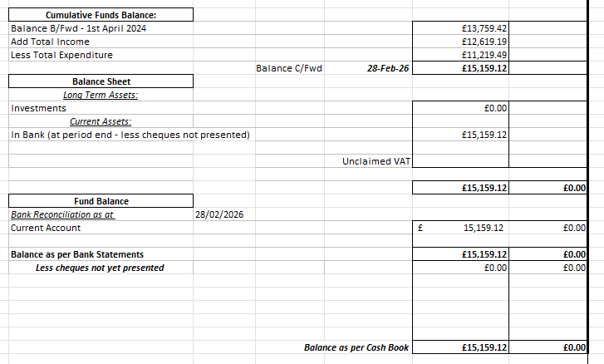
- Review planning applications
Status | Date | Planning No: | Site Address | Description | APC Comments | Decision
Registered | 25/03/2025 | P/2024/01181 | Mosley Primary School, Main Road, Anslow, Staffordshire, DE13 9QD | Formation of a designated pedestrian ramp access from the highway footpath to the school's main reception area. | Concerns raised with the ramp being directly opposite the pub car park and the corner is dangerous for crossing with no pavement. Concern raised for the further loss of car parking spaces and impact this will have on the pub. Accidents have already occurred at the spot proposed in adverse weather. Pedestrians the entrance for the school car park. | Permits
Registered | 26/08/2025 | P/2025/00792 | The Willows , New Gate Court Main Road, Anslow, Staffordshire, DE13 9FH | Two storey rear extension and installation of first floor side dormer. | No comments from the parish council.
Registered | 03/09/2025 | P/2025/00785 | Dovecote Barn, Outwoods Lane, Burton Upon Trent, Staffordshire, DE13 9QU | Change of use of land and construction of internal access track to form vehicular access to residential dwelling and equestrian uses with associated external alterations and landscaping. | No comments from the parish council. | Permits
Registered | 14/11/2025 | P/2025/01276 | HANBURY PARK GATE BURTON ROAD NEEDWOOD DE13 9PE | Demolition of single storey side extension, erection of two storey front and side extensions, raising of the eaves and ridge height, erection of dormer windows, and alterations to fenestrations and installation of cladding. | No comments from the parish council.
Registered | 02/12/2025 | P/2025/01317 | THE BIRCHES MAIN ROAD ANSLOW DE13 9QD | Erection of first floor side and single storey rear extensions with roof terrace. | No comments from the parish council. | Permits
New | 25/02/2026 | P/2026/00182 | THATCH COTTAGE MAIN ROAD ANSLOW DE13 9QE | Listed Building Application to repair facia and replace external waste pipes on the east elevation, remove sloping concrete flaunching on the front and west walls, restore the front porch, replace rear door, remove internal partition wall, raise the sloping plasterboard ceilings, remove black paint from the timber frame in the central reception room, remove modern external fittings, lower the level of the hearth and replace surface, replace external lighting and installation of central heating boiler flue.

New | 04/03/2026 | P/2026/00211 | BELMOT FARM BELMOT ROAD NEEDWOOD DE13 9PH | Erection of an agricultural building for the storage of animal feed/ hay.
P/2026/00182 - The council were happy this work is being undertaken and support the application
P/2026/00211 - The parish council has no comments

Action: Clerk to add comments to ESBC Planning Portal
- To review and approve the website renewal
It was agreed that Anslow Parish Council would proceed with DRH websites with a cap at £1500. It was agreed for this to include an app and the £150 annual maintenance.
Action: Clerk to instruct the redesign of the new website
- To discuss The Bell as a Community Asset
Members were advised that a small group within the village has sought professional advice in relation to the potential registration of The Bell public house as an Asset of Community Value.
It has been established that the freehold of the property is not currently available, and it has been confirmed that the brewery intends to invest in the business. It was also explained that Marston’s have indicated they would inform the group should circumstances change.
The first stage of the process is to register the property with East Staffordshire Borough Council as an Asset of Community Value. The application form has been completed and, subject to ratification by the Parish Council, will be submitted to East Staffordshire Borough Council.
Action: Clerk to send the ACV application to the councillors for approval
- To review and approve the Risk Register 2026
The risk register was reviewed and approved.
Action: Clerk to update the website
- To review and approve the Asset Register 2026
The Asset Register was reviewed and approved.
Action: Clerk to update the website
- To review and approved the Ear-Marked Funds 2026/2027
This was agreed as follows:
Amount held at  28th February 2026 | Purpose of reserve
£5,000 | Parish Initiatives
- To review and approve the Financial Regulations 2026
The Financial Regulations was reviewed and approved.
Action: Clerk to update the website
- To review and approve the Publication Scheme 2026
The Publication Scheme was reviewed and approved.
Action: Clerk to update the website
- Councillors’ Reports: Parish Cllrs, SCC Cllr Phillip White, ESBC Cllr Russell Lock and ESBC Cllr Simon Gaskin
It was agreed to organise a further village clean up when the weather is better.
Cllr Lock explained that a presentation on the future of Tutbury Castle was undertaken last month and it will be open at Easter. This will include a new café and children’s area as well as a marquee that will undertake Sunday dinners etc…
Cllr Thompstone discussed some fencing that is being undertaken and offered the village hall committee to do any planting should they wish.
The caravan was discussed. This has been reported to ESBC and Cllr Lock agreed to chase this up.
It was agreed to undertake a meeting with church on 22nd March 2026 at 1pm.
Action: Clerk to arrange meeting with the church

Meeting closed 19:47pm

The next Parish Council Meeting is Wednesday 13th May 2026
Parish Council Information can be found on the internet at – www.anslowparishcouncil.org.uk

Signed by the Chairman of the Parish Council
Name:

Date:

