Minutes of the Annual Meeting of the Parish Council – Wednesday 13th May 2026
Present; Councillors: Cllr Jeans, Cllr Bull, Cllr Bailey, Cllr Thompstone, Cllr Tomlinson
Also present C Holmes; Borough Cllr Lock; 8 Parishioner

- Election of Chairman & Signing of Declaration of Acceptance of Office

Cllr Bull proposed Cllr Jeans for Chairman. Seconded by Cllr Thompstone. All in favour

- Election of Vice Chairman & Signing of Declaration of Acceptance of Office

Cllr Tomlinson proposed Cllr Bull. Seconded by Cllr Thompstone. All in favour

- Apologies for Absence

Cllr Reader, Cllr Page, Borough Cllr Smedley

- Declarations of Interest

None
- Chair’s Welcome

The chair offered a welcome to all those who have attended.

- Public Forum

None.

- Minutes of the Meeting of the Parish Council held on 4th March 2026
All agreed to be a true record of the meeting.
Action: Clerk to convert to upload to website

- Matters arising from those minutes.

None.

- Review planning applications.
Status | Date | Planning No: | Site Address | Description | APC Comments | Decision
Registered | 26/08/2025 | P/2025/00792 | The Willows , New Gate Court Main Road, Anslow, Staffordshire, DE13 9FH | Two storey rear extension and installation of first floor side dormer. | No comments from the parish council.
Registered | 14/11/2025 | P/2025/01276 | HANBURY PARK GATE BURTON ROAD NEEDWOOD DE13 9PE | Demolition of single storey side extension, erection of two storey front and side extensions, raising of the eaves and ridge height, erection of dormer windows, and alterations to fenestrations and installation of cladding. | No comments from the parish council.
Registered | 25/02/2026 | P/2026/00182 | THATCH COTTAGE MAIN ROAD ANSLOW DE13 9QE | Listed Building Application to repair facia and replace external waste pipes on the east elevation, remove sloping concrete flaunching on the front and west walls, restore the front porch, replace rear door, remove internal partition wall, raise the sloping plasterboard ceilings, remove black paint from the timber frame in the central reception room, remove modern external fittings, lower the level of the hearth and replace surface, replace external lighting and installation of central heating boiler flue. | The council were happy this work is being undertaken and support the application. | Permits

Registered | 04/03/2026 | P/2026/00211 | BELMOT FARM BELMOT ROAD NEEDWOOD DE13 9PH | Erection of an agricultural building for the storage of animal feed/ hay. | The parish council has no comments | Permits
New | 12/05/2026 | P/2026/00426 | CHURCH FARM TEA ROOMS  HANBURY ROAD  ANSLOW GATE  DE13 9QT | Change of use of land and erection of stables, animal barn, sensory play barn, pigsty, and farm entrance (kiosk) to form an extension to the existing animal education centre & tea rooms, including installation of outside natural play equipment & package treatment plant & alterations to car parking to form additional spaces, landscaping and associated facilities | The parish council offered their support for this planning application allowing for better parking and more jobs into the village.
P/2026/00426 - The parish council offered their support for this planning application allowing for better parking and more jobs into the village.

Action: Clerk to add comments to ESBC Planning Portal
- Receive Borough and County Councillor reports
None received.
- To review and approve the Data Audit 2026
The Data Audit was reviewed and approved.
Action: Clerk to add to the website
- Annual Governance & Accountability Return
12a: Minute to accept in the internal auditor’s report.
The internal report was accepted by the council. The certificate of exemption was also accepted.
12b: Complete the Annual Governance Report
The Annual Governance report was signed by the RFO & Chair
12c: Complete the Accounting Statement for 2025/2026
The Accounting Statement was signed by the RFO & Chair
A thank you was issued to the internal auditor for their assistance.
Action: Clerk to send to Mazars, add to website & noticeboard
- Clerk’s Report: to include banking changes, finance & correspondence.

- CORRESPONDENCE & ONGOING MATTERS

Church Meeting organised and attended by Parish Councillors

Bin sitings still being chased with East Staffs Borough Council

Community Asset application for The Bell Inn sent to the monitoring officer for review

Parishioner correspondence about the road closures in the village.

Invitation to parish councillors to join MP Jacob Collier to discuss the local government reorganisation. It was agreed for Cllr Jeans to attend.

Action: Clerk to inform of Cllr Jeans attendance to the zoom meeting.

- FINANCE
Date | Online Payment Number | Category | Invoice Detail | Invoice Amount
 |  |  |  | Net | VAT | Gross
01/04/2026 | OLP 2026-2027 - 01 | Clerks Salary | Salary | -£ 456.85 |  | -£ 456.85
17/04/2026 |  | Precept |  | £ 6,571.00 |  | £ 6,571.00
20/04/2026 |  | Bank Interest | Charges | -£ 4.25 |  | -£ 4.25
01/05/2026 | OLP 2026-2027 - 02 | Clerks Salary | Salary | -£ 456.85 |  | -£ 456.85
13/05/2026 | OLP 2026-2027 - 03 | Website | Hosting | -£ 12.99 | -£ 2.60 | -£ 15.59
13/05/2026 | OLP 2026-2027 - 04 | Planters & Village Maintenance | Memorial Bench | -£ 332.50 | -£ 66.50 | -£ 399.00
13/05/2026 | OLP 2026-2027 - 05 | SPCA Membership |  | -£ 354.78 |  | -£ 354.78
13/05/2026 | OLP 2026-2027 - 06 | Room Hire | March | -£ 20.00 |  | -£ 20.00
13/05/2026 | OLP 2026-2027 - 07 | Insurance |  | -£ 507.81 |  | -£ 507.81
13/05/2026 | OLP 2026-2027 - 08 | Misc & Donations | Apm Stickers | -£ 42.46 | -£ 8.49 | -£ 50.95
13/05/2026 | OLP 2026-2027 - 09 | Clerks Salary | HMRC | -£ 101.23 |  | -£ 101.23
13/05/2026 | OLP 2026-2027 - 10 | Clerks Salary | HMRC | -£ 101.23 |  | -£ 101.23

All payments agreed by the council

Balance at 30.04.2026
Treasurers Account - 56980463 | £20,509.60

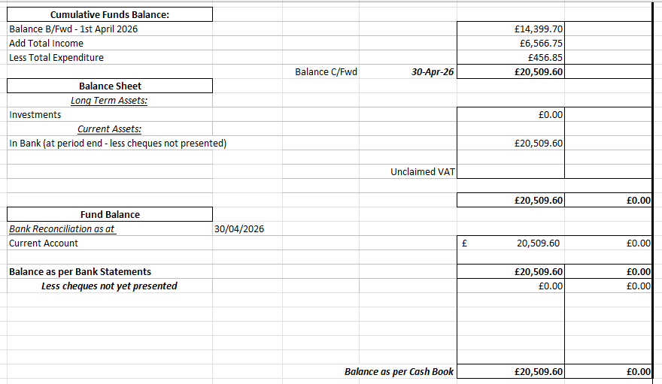
- Councillors’ Reports
The flood sign remaining outside of Little Monsters was discussed and it was agreed to asked Staffs CC to remove them.
Action: Clerk to ask Staffs CC to remove signs.

Meeting closed at 19:58pm

The next Parish Council Meeting is– 8th July 2026

Parish Council Information can be found on the internet at – www.anslowparishcouncil.org.uk

Signed by the Chairman of the Parish Council

Name:

Date:

